**NETWORK OF INDIAN RAILWAYS**

Contributors: Neil D’Souza, Nikhil Kishore, Priya Khokher, Sachin Verma

**ABSTRACT**

Transportation networks are an important part of a city and function like the veins and arteries that help move people around. Especially in India which has such a vast population, effective transportation is an important issue. Which city in India is the best connected by railways? What is the best route between two cities? This project aims to answer these questions by creating and analyzing a network of cities in the India connected by railways.

**DATA**

The railways stations in India were taken as the nodes and the connections between them were taken as the edges [1] for the network.

**METHODOLOGY**

Initially, data on Open Street Map [2] was looked at to geocode (latitude and longitude) the railway stations as this was not present in the data from the Indian government site but there were issues with names and duplicates that made it ineffective to use. The Indian railway data contained all the connections between various stations, the unique stations were extracted from this to make a node list. The node list was geocoded using the Google Maps API [3] while the original data was used to make the edge list. Only stations where trains depart or terminate (major stations) were used and not the intermediary ones as this presented the complexity of multiple routes and multiple trains. The lists were then read into an IPython Notebook to create the network of railways.

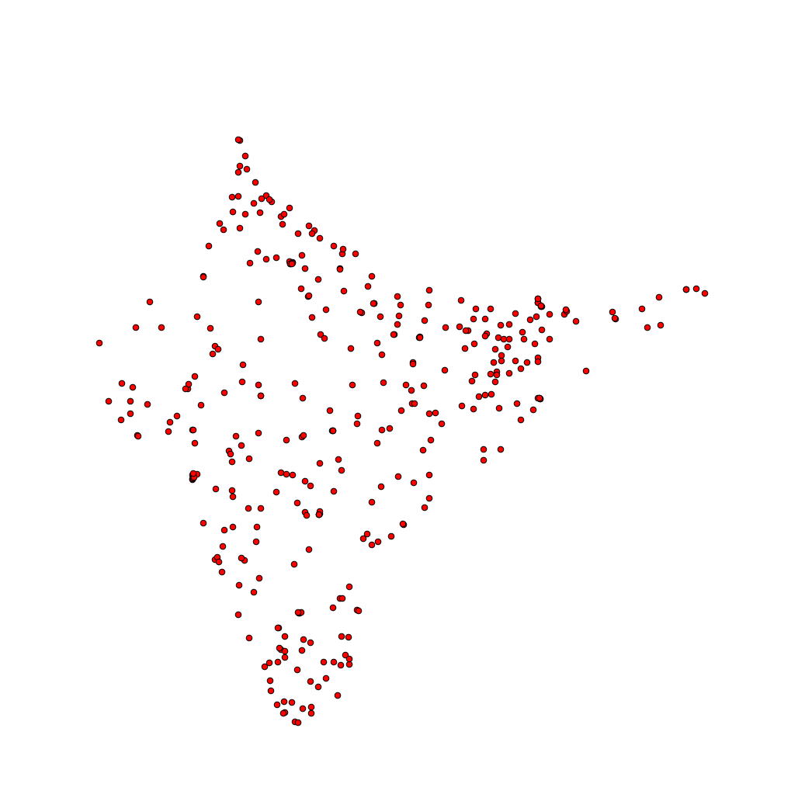

Mapping of all the major railway stations

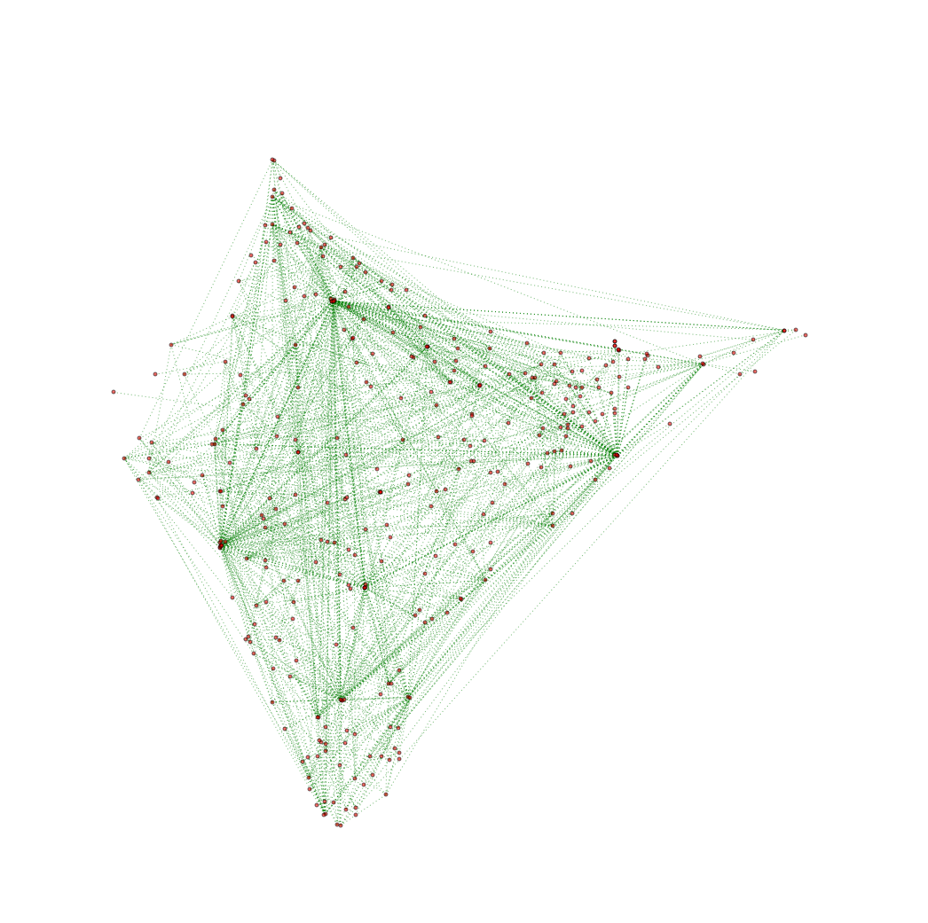

Connections between the railway stations

**ANALYSIS**

Various centrality measures were computed which indicated that Howrah Junction in Howrah, West Bengal is the most important station in most aspects.

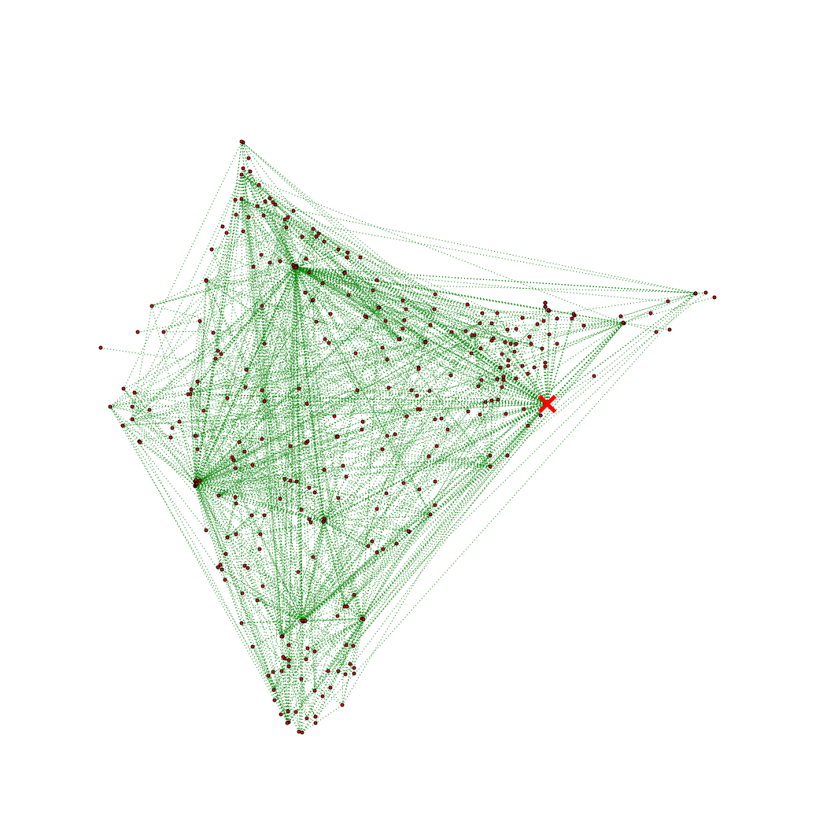

Location of Howrah Junction

* Degree centrality: 1|Howrah Junction - 68

2| New Delhi - 48

3|Lokmanya Tilak - 46

* Eigen-vector centrality: 1|Howrah Junction - 0.275527717266

2|Chennai Central - 0.224605874594

3|New Delhi - 0.213179694338

* Betweenness centrality: 1|Howrah Junction - 0.179544117088

2|New Delhi - 0.109405168355

3|Lokmanya Tilak - 0.10671055416

* Closeness centrality: 1|Howrah Junction - 0.472727272727

2|Chennai Central - 0.451871657754

3|Lokmanya Tilak - 0.446499339498

* Pagerank centrality: 1|Howrah Juntion - 0.0278550559208

2|New Delhi - 0.0187917372527

3|Lokmanya Tilak - 0.0179238578082

Shortest paths were calculated between the various stations. After excluding loop edges, the pairs with the lowest shortest path of 2 are displayed in the table below.

|  |  |
| --- | --- |
| SOURCE | DESTINATION |
| Diva | Sawantwadiroad |
| Allahabadjn | Bulandshahr |
| Singrauli | Varanasijn |
| Nizamabad | Lokmanyatilakt |
| Kurseong | Tokurseong |
| Banihal | Srinagar |
| Mavlijn | Marwarjn |
| Manmadjn | Lokmanyatilakt |

The highest shortest path of 9 was between Indore and Silghat Town comprising of Indore, Akola, Kacheguda, Chennaiegmore, Dibrugarh, Delhi, Alipurduar, Dhubri and Silghat Town.

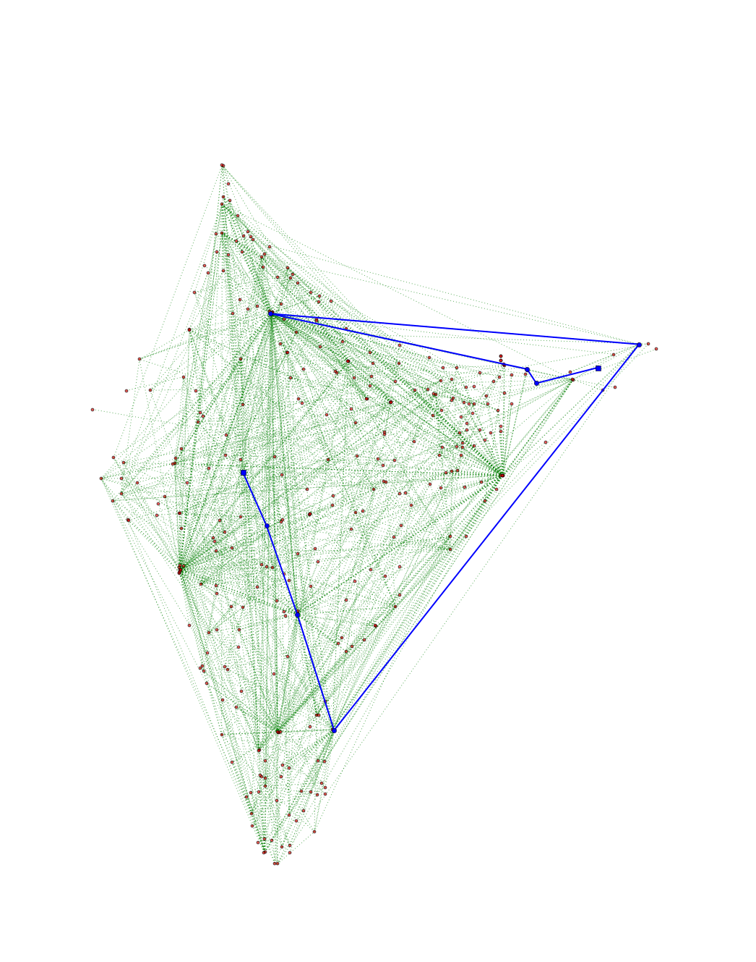

Mapping of the highest shortest path

**INDIVIDUAL CONTRIBUTION**

The initial project idea as well as the analysis performed and how it should be interpreted. Some assistance with the curation of the data. The complete write up of the project report and presentation.

**CONCLUSION**

Howrah Junction in West Bengal holds most importance in the Indian railway network which may be due to the fact that it was one of the first railway stations and is located near a port. It is followed by a tie between New Delhi (with higher degree, pagerank and betweeness centrality values) and Chennai Central (with higher closeness and eigen-vector centrality values).

**REFERENCES**

1. “Railway connections”,

<https://data.gov.in/catalogs/sector/Transport-9383?query=railway&sort_by=search_api_relevance&sort_order=DESC&items_per_page=9>

1. “Station names and coordinates”, <http://www.openstreetmap.org/export#map=4/17.48/77.87>
2. “Google Maps Geocoding API”, <https://developers.google.com/maps/documentation/geocoding/intro>